Lab 6 - Configure work classification rulesets for Unified Routing
Duration: 20 mins

Introduction:
In this lab, you will learn how to configure work classification and routing rules in the Copilot Service admin center. These rules help automate how customer issues are categorized and routed to the appropriate queues based on predefined conditions, such as customer type or service level. You will create a work classification ruleset and a route-to-queue ruleset to streamline case management within the contact center.

Task 1 - Create a Work Classification Ruleset
In this task, you will create a logical ruleset named Contoso ruleset to classify incoming cases based on customer details. You will define a condition that sets the service level to Gold when the customer is Trey Research, helping prioritize high-value customer requests.
- In Copilot Service admin center, navigate to Workstreams under Customer support group and select Contoso chat workstream.
- 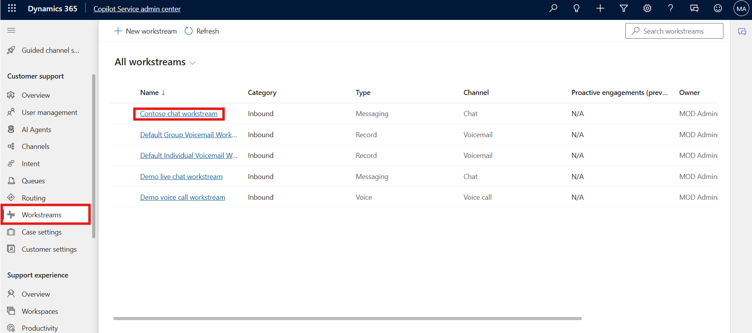
- On the Contoso chat workstream page, in the Routing rules area, select + Create ruleset next to Work classification (optional) option.
- 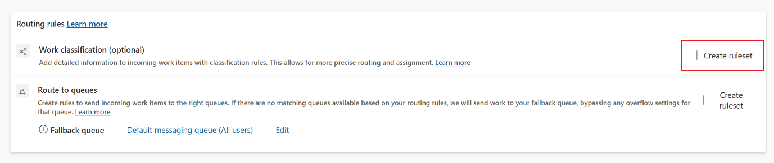
- On the Work classification page, select Create new.
- 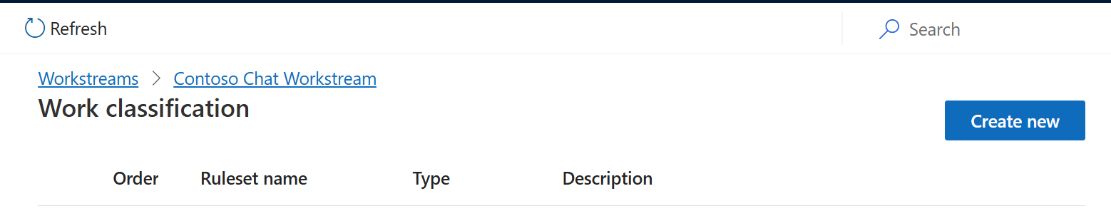
- In the Create work classification ruleset dialog, select Logical rules under Rule type and then enter the following details.
  - Name – !!Contoso ruleset!!
  - Description – !!Contoso ruleset!!
  - Click Create
- 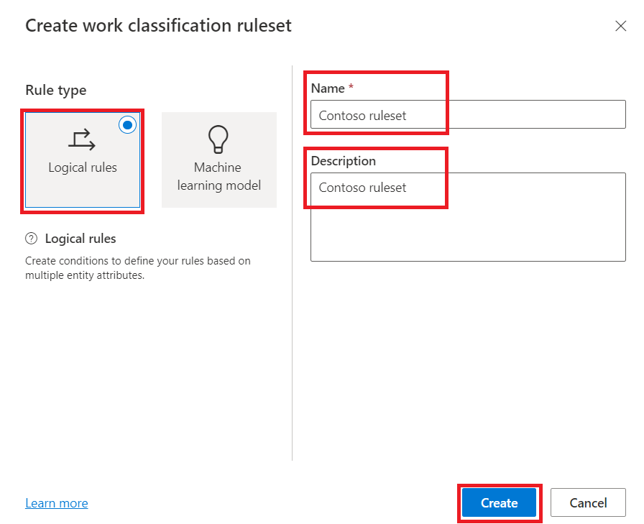
- In the Decision list area, select + Create Rule.
- 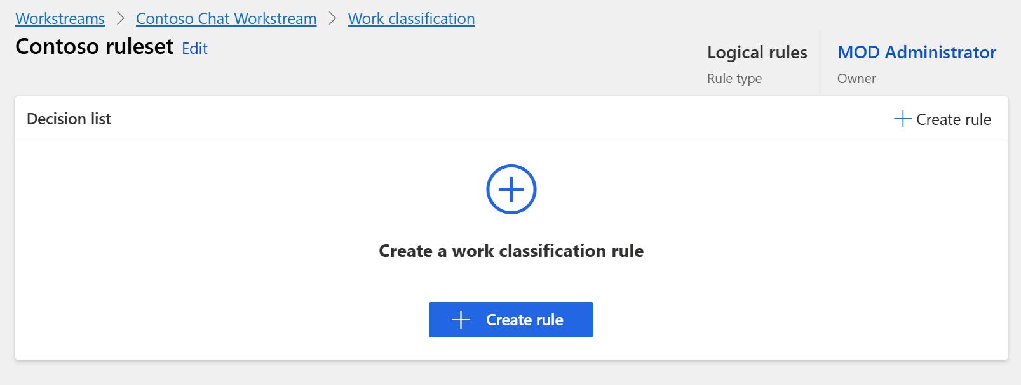
- On the Create work classification rule dialog, enter the following details in the Conditions area.
  - Rule Name - !!Set service level!!
  - Select + Add and then select Add related entity.
- 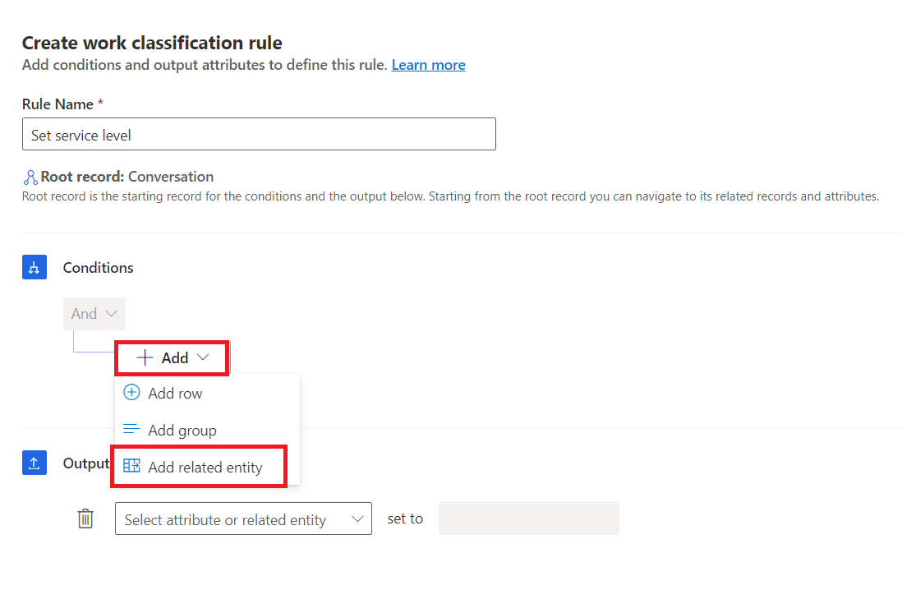
- Add Issue (Case) entity in the first block.
- Create the following condition: Customer Equals Trey Research
- In the Output area, enter the following: Issue (Case), Service Level set to Gold.
- Click Create.
- 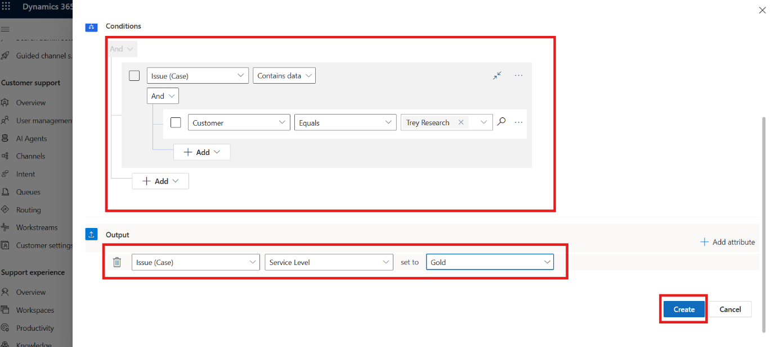
- The Set service level rule is listed under Decision list.
- 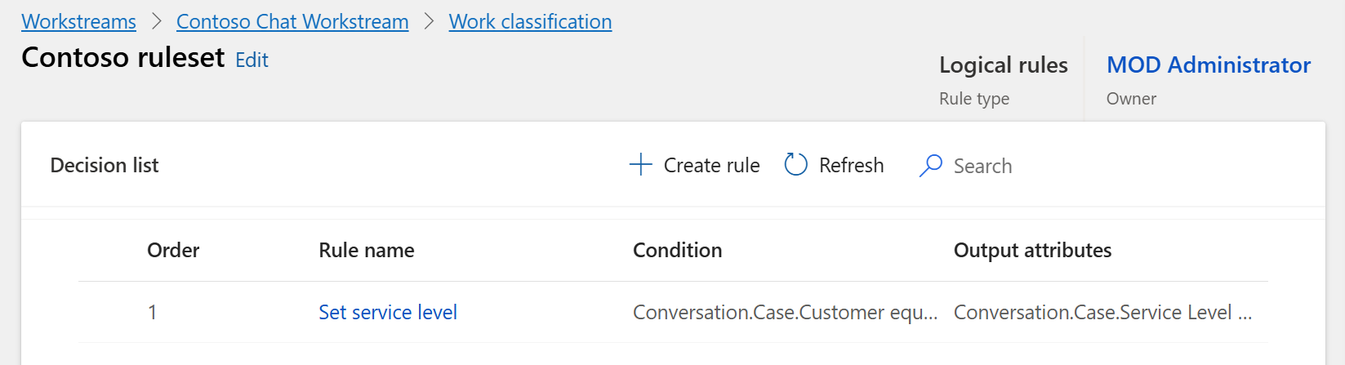

Task 2: Create a Route-to-Queue Ruleset
In this task, you will configure a routing ruleset named Based on Gold Level to automatically direct cases with a Gold service level to the Contoso queue for supervisors. This ensures that priority cases are assigned to the right support team promptly.
- In Dynamics 365 Copilot Service admin center, from top select Contoso chat workstream.
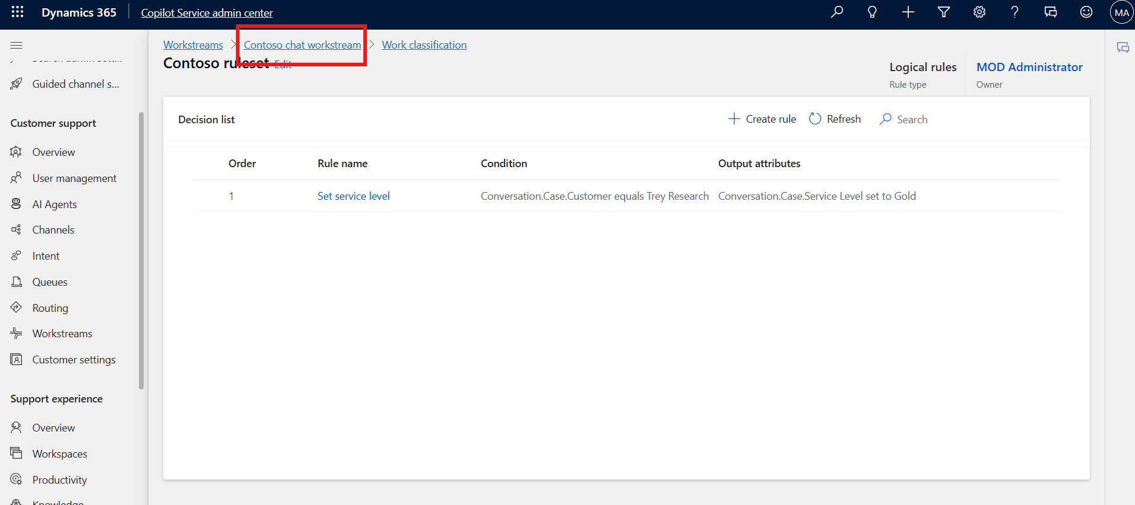
- In the Routing rules area, select + Create ruleset next to Route to queues.
- 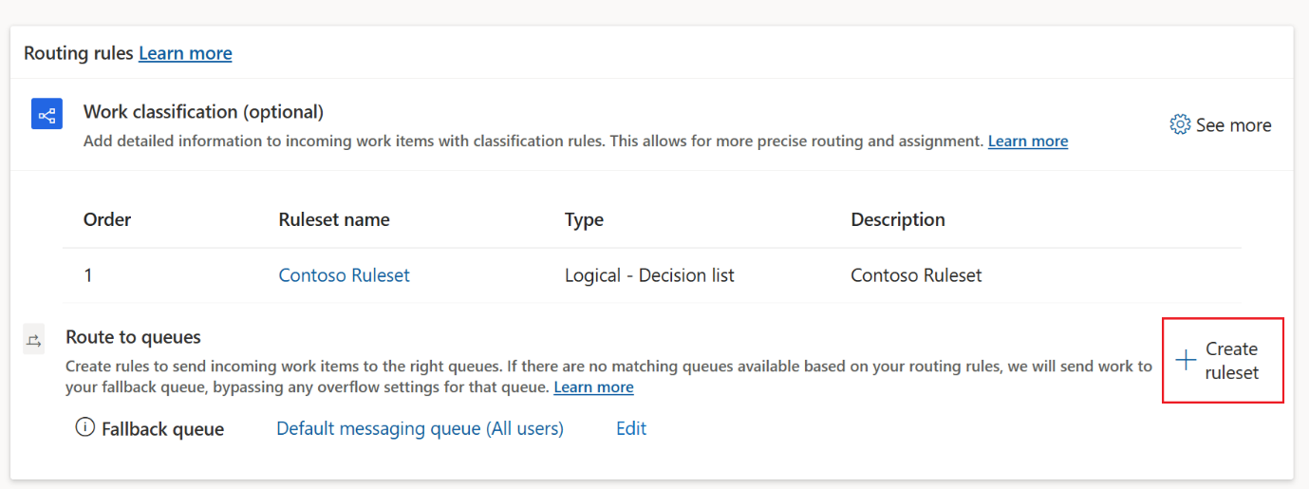
- On the Create route-to-queues ruleset pane, in the Name field enter!!Based on Gold Level!!. In the Description field enter !!Rule based on Gold level!!.
- Select Create.
- 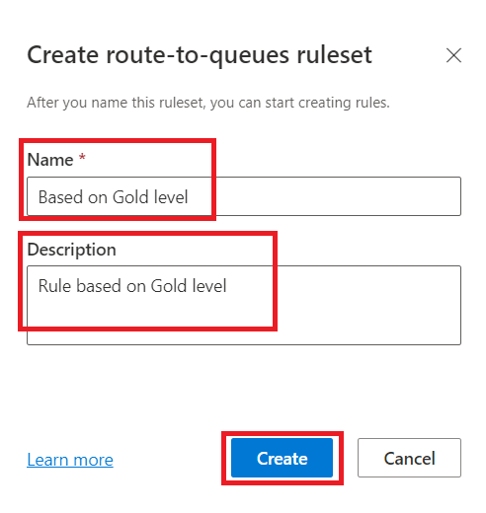
- In the Decision list area, select + Create Rule.
- 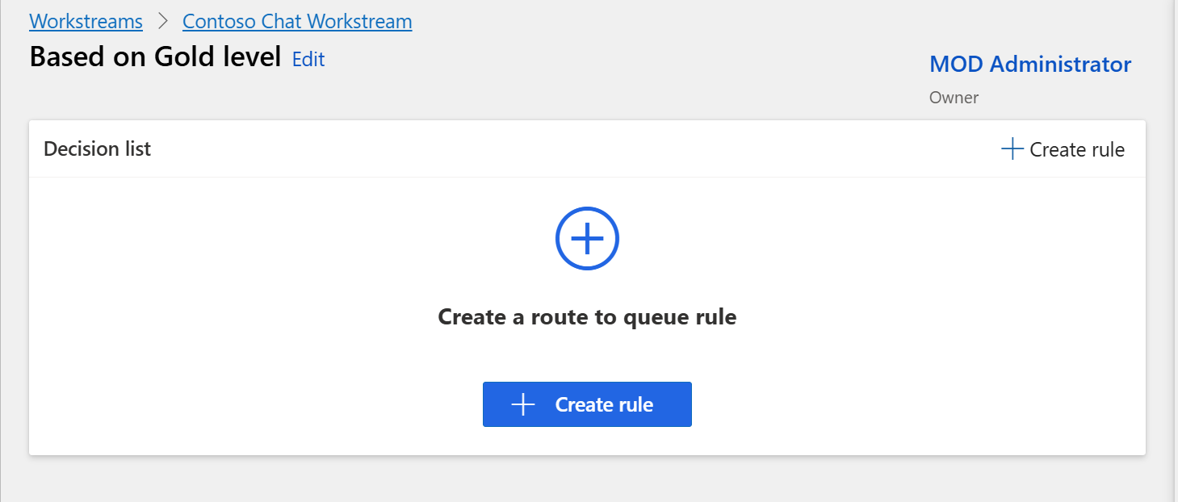
- On the Create route to queue rule dialog, enter the following details.
  - Name – !!Based on Gold level!!
  - Select + Add and then select Add related entity.
- 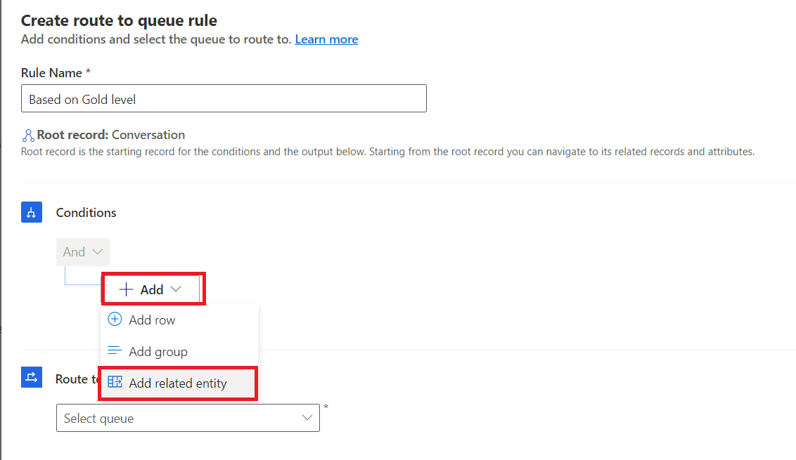
- Add Issue (Case) entity in the first block.
- Create the following condition: Service level Equals Gold.
- In the Route to queues area, select Contoso queue for supervisors.
- Click Create.
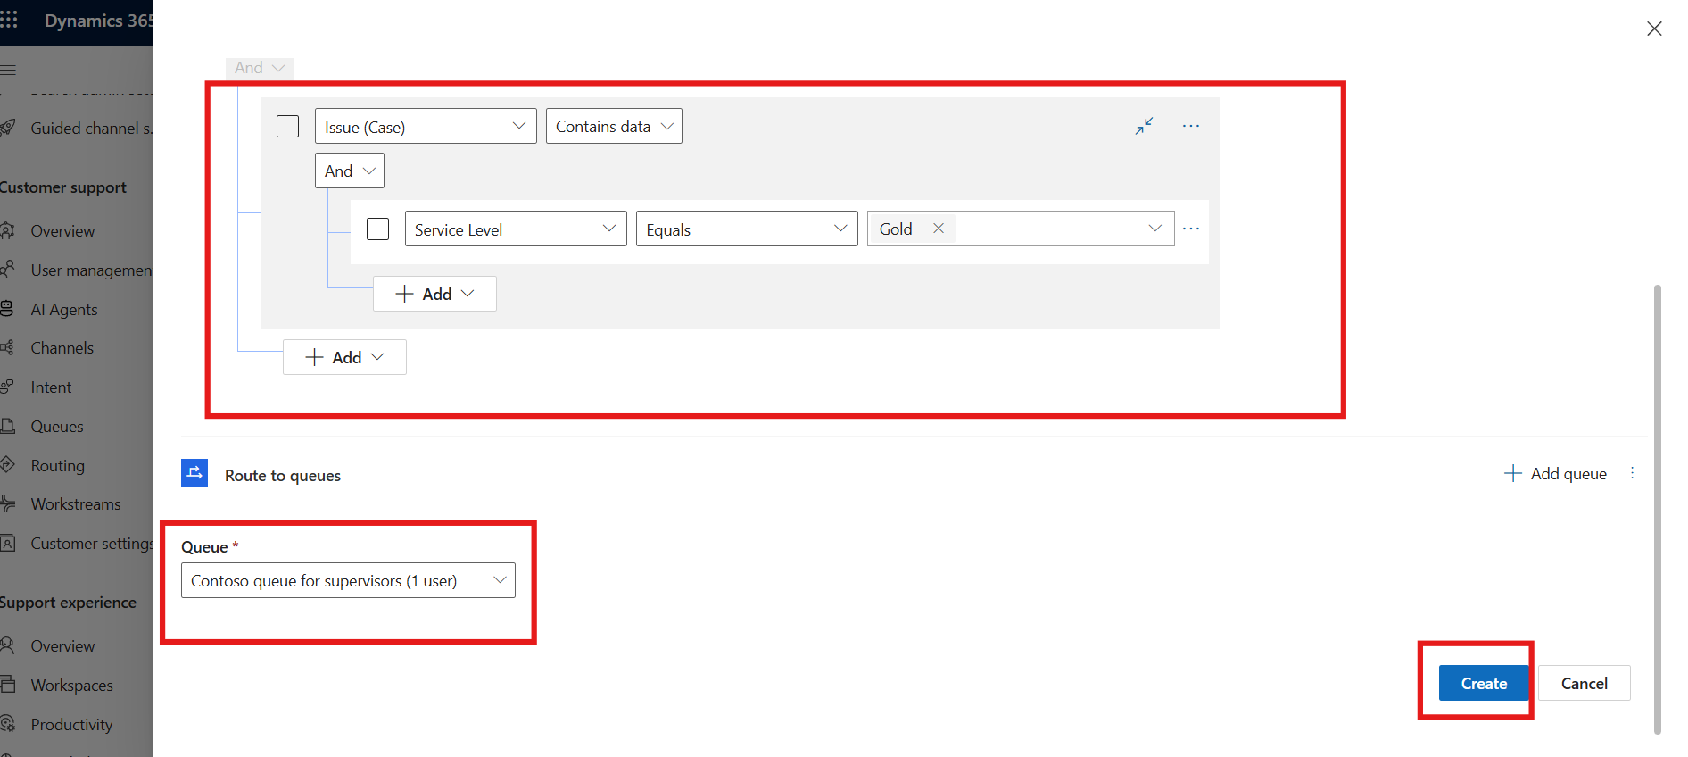
- The Based on Gold level rule is listed under Decision list.

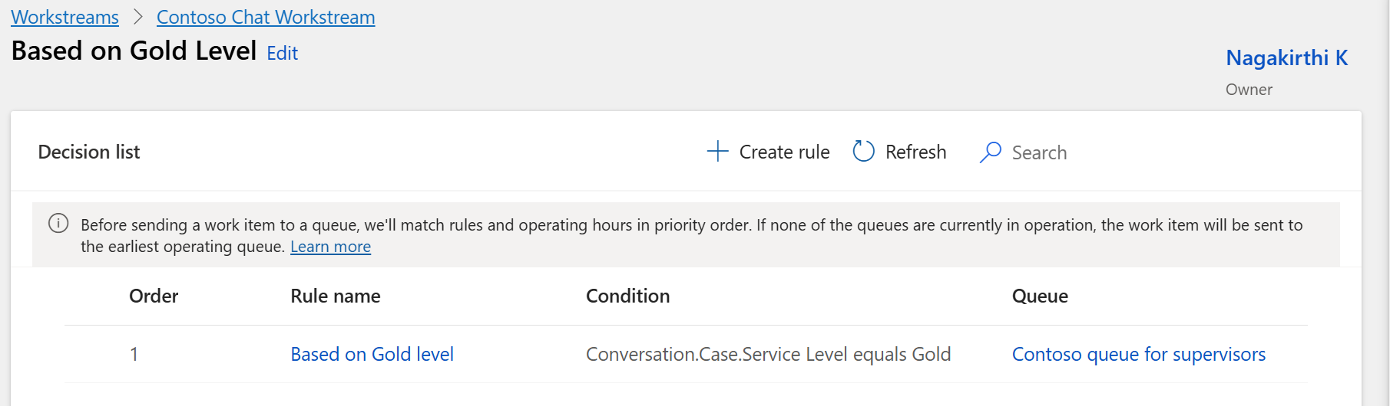

Conclusion:
By completing this lab, you have successfully created and configured both work classification and routing rules in the Copilot Service admin center. These rules enable automated case prioritization and intelligent routing, ensuring efficient handling of customer interactions based on service levels and predefined business logic.

